Electromagnetic Flow Meters

Electromagnetic Flow Meters is a volumetric flow meter which is ideally used for waste water applications and other applications that experience low pressure drop and with appropriate liquid conductivity required.
The device doesn’t have any moving parts and cannot work with hydrocarbons and distilled water.

Electromagnetic Flow Meters
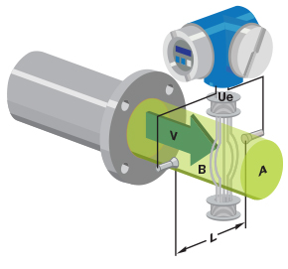

Principle of Magnetic Flow Meter Based on Faraday’s Law
Magnetic flow meters works based on Faraday’s Law of Electromagnetic Induction. According to this principle, when a conductive medium passes through a magnetic field B, a voltage E is generated which is proportional to the velocity v of the medium, the density of the magnetic field and the length of the conductor.
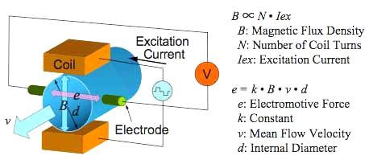
In a magnetic flow meter, a current is applied to wire coils mounted within or outside the meter body to generate a magnetic field. The liquid flowing through the pipe acts as the conductor and this induces a voltage which is proportional to the average flow velocity.
This voltage is detected by sensing electrodes mounted in the Magflow meter body and sent to a transmitter which calculates the volumetric flow rate based on the pipe dimensions.

Mathematically, we can state Faraday’s law as

E is proportional to V x B x L
[E is the voltage generated in a conductor, V is the velocity of the conductor, B is the magnetic field strength and L is the length of the conductor].
It is very important that the liquid flow that is to be measured using the magnetic flow meter must be electrically conductive. The Faraday’s Law indicates that the signal voltage (E) is dependent on the average liquid velocity (V), the length of the conductor (L) and the magnetic field strength (B). The magnetic field will thus be established in the cross-section of the tube.
Basically when the conductive liquid flows through the magnetic field, voltage is induced. To measure this generated voltage (which is proportional to the velocity of the flowing liquid), two stainless steel electrodes are used which are mounted opposite each other.
The two electrodes which are placed inside the flow meter are then connected to an advanced electronic circuit that has the ability to process the signal. The processed signal is fed into the microprocessor that calculates the volumetric flow of the liquid.

Electromagnetic Flow Meters Formula:
Electromagnetic flow meters use Faraday’s law of electromagnetic induction for making a flow measurement. Faraday’s law states that, whenever a conductor of length ‘l’ moves with a velocity ‘v’ perpendicular to a magnetic field ‘B’, an emf ‘e’ is induced in a mutually perpendicular direction which is given by

e = Blv …(eq1)
where
B = Magnetic flux density (Wb/m2)
l = length of conductor (m)
v = Velocity of the conductor (m/s)
The volume flow rate Q is given by

Q = (πd²/4) v …(eq2)
where
d = diameter of the pipe
v = average velocity of flow (conductor velocity in this case)
From equation (eq1)

v = e/Bl

Q = πd²e/4Bl

Q = K e
where K is a meter constant.
Thus the volume flow rate is proportional to the induced emf. In Practical applications we have to enter the meter constant ‘K’ value in magnetic flow meter which is available in vendor catalog/manual.

Limitations of electromagnetic Flow Meters
(i) The substance being measured must be conductive. Therefore, it can’t be employed for metering the flow rate of gases and steam, petroleum products and similar liquids having very low conductivity.
(ii) To render the meter insensitive to variations in the resistance of liquid, the effective resistance of the liquid between the electrodes should not exceed 1% of the impedance of the external circuit.
(iii) It is a very expensive device.
(iv) As the meter always measures the volume rate, the volume of any suspended matter in the liquid will be included.
(v) The pipe must run full, in case regulating valves are installed upstream of the meter.

Advantages of Electromagnetic Flow Meter
(i) The obstruction to the flow is almost nil and therefore this type of meters can be used for measuring heavy suspensions, including mud, sewage and wood pulp.
ii) There is no pressure head loss in this type of flow meter other than that of the length of straight pipe which the meter occupies.
(iii) They are not very much affected by upstream flow disturbances.
(iv) They are practically unaffected by variation in density, viscosity, pressure and temperature.
(v) Electric power requirements can be low (15 or 20 W), particularly with pulsed DC types.
(vi) These meters can be used as bidirectional meters.
(vii) The meters are suitable for most acids, bases, water and aqueous solutions because the lining materials selected are not only good electrical insulators but also are corrosion resistant.
(viii) The meters are widely used for slurry services not only because they are obstruction less but also because some of the liners such as polyurethane, neoprene and rubber have good abrasion or erosion resistance.
(ix) They are capable of handling extremely low flows.

Disadvantages of Magnetic Flow Meter
(i) These meters can be used only for fluids which have reasonable electrical conductivity.
(ii) Accuracy is only in the range of ± 1% over a flow rate range of 5%.
(iii) The size and cost of the field coils and circuitry do not increase in proportion to their size of pipe bore. Consequently small size meters are bulky and expensive.

Applications of Magnetic Flow Meters
This electromagnetic flow meter being non intrusive type, can be used in general for any fluid which is having a reasonable electrical conductivity above 10 microsiemens/cm.
Fluids like sand water slurry, coal powder, slurry, sewage, wood pulp, chemicals, water other than distilled water in large pipe lines, hot fluids, high viscous fluids specially in food processing industries, cryogenic fluids can be metered by the electromagnetic flow meter.

